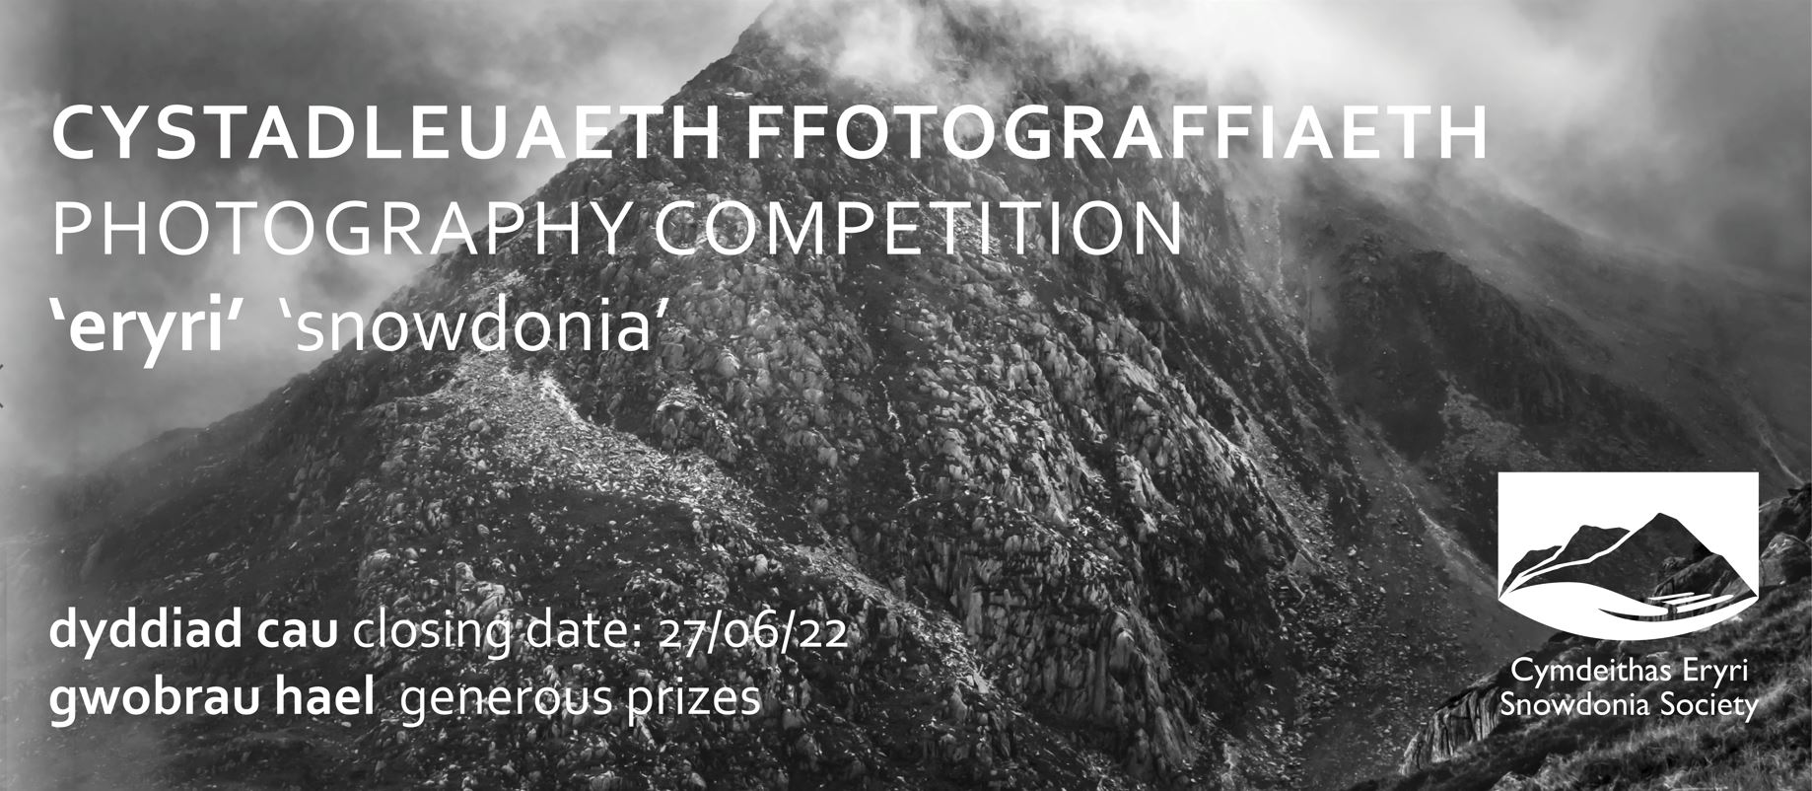

The subject for the Snowdonia Society Photographic Competition 2022 is ‘Snowdonia’ The theme is open to individual interpretation but entries must capture some of the character of Snowdonia. Pictures of pets, cultivated plants as well as wildlife in captivity are not eligible.
Rare animals... unique plants... secret hidey holes... different views... unusual angles... Snowdonia is brimming with hidden gems - right in front of our eyes. Do you have a photo which reflects the quality of Snowdonia?
- Landscape format (not portrait)
- 1 entry per person in high digital format (if format is too low it will not be eligible for entry)
- Provide your contact details
- Provide location the photo was taken
T&Cs
1) Photos of pets, cultivated plants as well as wildlife in captivity are not eligible.
2) The subject of the image must be taken within the Snowdonia National Park boundary. Photographs from the Blaenau Ffestiniog region, Barmouth and Fairbourne are eligible. Entrants must provide the Snowdonia Society with a location of their photograph.
3) Entrants may only submit 1 photograph through digital format only.
4) Images may be digitally enhanced to remove spots or scratches, but not manipulated. The competition judges reserve the right to exclude any image they believe may have been excessively treated so as to alter its authenticity.
5) The competition is open to all, except employees of the Snowdonia Society and competition judge. Entrants under the age of 16 years need to have parent or guardian consent to enter.
6) Entrants must not be professional photographers (a professional photographer will be considered to be someone who makes more than half their annual income from the sale of their photographs).
7) Each entry should be marked with the entrant’s name, address, email, contact telephone number and details of where the photograph was taken as per the form online. This form must be completed for your submission to be valid.
8) Entries must be full resolution and in landscape format. Entrants may also use the file transfer service WeTransfer or a similar application to submit their photograph as an alternative.
9) The competition closes at 9am on 27/06/22. Competition results will be announced on the 18/7/22.
10) All entries will be judged by a panel of judges. One panel of judges will first select a long list of photographs from which an outside judge will select the top 3 The Finalists selected by the judges shall appear in the Snowdonia Society Calendar 2023, to be sold in aid of the Snowdonia Society.
11) All entrants grant to the Snowdonia Society further rights to publish and exhibit their photographs in print, on their respective websites or in any other media. No fees will be payable for any of the above uses. The Snowdonia Society also reserves the right to crop the final 12 images in order to fit the landscape format of the chosen calendar printers.
12) All entries must be the original work of the entrant and must not infringe the rights of any other party. The entrants must be the sole owner of copyright in all photographs entered and must have obtained permission of any people featured in the entries or their parents/guardians if children under 16 are featured. Further, entrants must not have breached any laws when taking their photographs.
13) Prior to submission, entrants must not have offered any of their entries for sale, been paid for any publication of their entry or entered their photograph in another competition.
14) Entrants will retain copyright in the photographs that they submit to the Snowdonia Society. While we make every effort to credit photographers, including in printed reproductions of their work, we cannot guarantee that every use of the photographs will include the photographers' names.
15) By entering, entrants will be deemed to have agreed to be bound by these rules and the Snowdonia Society reserves the right to exclude any entry from the competition at any time and in its absolute discretion if the Snowdonia Society has reason to believe that an entrant has breached these rules.
16) The Snowdonia Society reserves the right to cancel this competition or alter any of the rules at any stage, if deemed necessary in its opinion, and if circumstances arise outside of its control.
17) If the winner is unable to be contacted after reasonable attempts have been made; the Snowdonia Society reserves the right to either offer the prize to a runner up, or to re-offer the prize in any future competition.
18) All winners will receive a copy of the Calendar and 50% off Snowdonia Society membership. There are also prizes for the 1st, 2nd and 3rd place winners.

